

**Parent Academic Night is Approaching! Save the Date**

Harris Creek Elementary

5:00-7:15 PM

Tracks 1 and 3

January 22nd

Parents and teachers will come together to support our children.

Raleigh Parks and Rec is partnering with us to help with childcare. Your children will be able to play games or participate in other activities. Please reserve a spot for them!

If you attended the first session please bring your goal sheet and blue folder with you.

Please return this portion to your child’s teacher if you plan to attend!

Teacher name(s)______________________________________________

Student Name(s) _____________________________________________

____ Yes! I will be attending the Academic Night

___ Yes! I will be bringing my children their ages are _____________

You can also RSVP on-line!

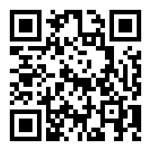

<https://goo.gl/forms/zJ5LhtvH8mpmqWfo2>